NOTE: WHEN USING THIS TEMPLATE FOR THE REVIEW VERSION OF YOUR PAPER, YOU MUST REMOVE ALL THE AUTHOR INFORMATION IN THE LINES BELOW AS WELL AS ANY AUTHOR IDENTIFYING INFORMATION WITHIN THE TEXT. THE REVIEW PROCESS IS DOUBLE BLIND (reviewers do not know who authors are and authors do not know who reviewers are). INCLUDE ALL AUTHOR INFORMATION WHEN USING THIS TEMPLATE FOR THE CAMERA READY VERSION (you submit the camera ready version once the review process is completed and after you received confirmation that your paper is accepted for publication).

 | Big Data Analytics Adoption by Microfinance Banks in Ibadan Metropolis, Oyo State, Nigeria
Research Paper
Volume X, Issue X, Month YYYY, ISSN 1936-0282 |  |  | (will be set by editors)
First author’s name  Affiliation  e-mail address |  | Second author’s name  Affiliation  e-mail address
Third author’s name
Affiliation
e-mail address
(Received month year, accepted month year)
or

First author’s name  Affiliation  e-mail address | Second author’s name  Affiliation  e-mail address
Third author’s name  Affiliation  e-mail address | Fourth author’s name  Affiliation  e-mail address

(Received month year, accepted month year)

ABSTRACT
Big data analytics (BDA) offers numerous benefits to help businesses and organisations make informed decisions that can improve their business operations. Micro Finance Banks (MFBs) generate an enormous amount of data from their daily business transactions, which has the potential to help them make better informed decisions. There is however, a dearth of information on how well MFBs in Nigeria have adopted BDA. The present study investigated the level of adoption of BDA by MFBs in Ibadan, the capital of Oyo State, Nigeria. Using a descriptive survey design, this study collected data from fifty-six personnel in twenty-eight licensed microfinance banks in the metropolis. Data which was collected using a structured questionnaire was analysed using Microsoft Excel 2019 and Statistical Package for the Social Sciences (SPSS) Version 20. Findings revealed that the BDA adoption index of MFBs in Ibadan is below average (1.92 on a scale of 1 to 4). The predominant analytic tool used by the MFBs is spreadsheet. Also, most of the organisations only deal with structured data which is stored using file systems or local databases. Although MFB personnels perceive the adoption of BDA to be beneficial to their organisation, lack of financial resources, and technological infrastructure were found to be the most crucial challenges to their adoption of BDA.

Keywords (Required)

Big Data, Big Data Analytics, Microfinance Banks, Adoption Index, ICT.

INTRODUCTION
Explosion in digital footprints through the use of innovative technologies such as social media networks, e-commerce websites, the internet of things (IoT), transactional processing systems (TPS) and search engines by individuals and organisations have resulted in rapid generation of massive electronic data. Nonetheless, the amount of data generated is still expected to increase tremendously in the future (Groenfeldt, 2012). This huge volume of data being generated at a very fast rate from various sources in different formats has resulted into what is now known as big data, which is typically characterized by its massive volume, variety of sources, rapid velocity, and diverse formats (Nadikattu, 2020). There has been a dramatic change and opportunities in data processing and storage which has influenced decision-making in business operations.
In the early 2000s, computer storage and processing power were faced with the challenge of handling the overwhelming volume of data being generated and that led to a data scalability crisis. The narrative has however changed now; in the words of Russom (2011, p.4) “Big data used to be a technical problem, now it’s a business opportunity”. Perception of what data is has shifted from being a mere product of computer processes to being a valuable asset. Klynveld Peat Marwick Goerdeler (KPMG) International Cooperative (2019) reports that data is now perceived to be the most significant asset to organizations and businesses across the globe, and organizations are willing to invest heavily into its disruptive potential in order to discover useful insights through the use of relevant analytic processes.
Big Data Analytics (BDA) involves the process of transforming structured, semi-structured, and unstructured data from various sources and of various formats like call logs, mobile banking transactions, online user-generated content, blog posts, tweets, online searches, and images amongst others into useful information by using computational techniques to uncover trends and patterns in a dataset (Zakir et al., 2015). BDA helps to derive useful and actionable insights from data generated by an organization. It also helps to uncover trends and metrics that would otherwise be lost without analytics (Frankenfield, 2021). The potential benefit of BDA in every sector and industry has given it the edge to be considered a business solution (Ogbuokiri et al., 2015).
BDA finds its application in every sphere where data is used and generated, either manually or electronically. Manufacturing companies record runtime, downtime, work queue for various machines, and this data can be analysed to make better plans which will enable the machines to operate at their peak capacities. It is also being used by content companies to keep their users clicking, watching, and re-organizing content to get another view or click and to predict what viewers will want to watch. In retails it determines the possible product that customers will want to purchase. It is used by business executives to capture data, create corporate value, and compete effectively (Attaran et al., 2018).

Banks like every other organisation generate tons of data from daily transactions. However, Financial Brand (2014) as cited in Amakobe (2015) reported that banks only employ a small part of the data to produce insights. Also, the report shows that banks that use BDA have a 4% market share advantage over banks that do not. Microfinance banks (MFBs) also known as micro-financial institutions (MFIs) play a vital role of being the financial service providers to the poor and underprivileged individuals and businesses, who are often overlooked or unserved by commercial banks. MFBs provide services such as credit, savings, micro-leasing, money transfer, and payment services. Microfinancing is regarded as an instrument for promoting economic growth and development since it supports grassroot enterprises, which has a knock-on effect on the poor’s well-being and economic standing (Okafor, 2000). As a result of this, many countries around the world have identified microfinancing as one of the major strategies to combat poverty.
Studies like Haddad et al. (2018), Kauffman and Riggins (2010) and Maroufkhani et al. (2020) reveal a dearth of empirical studies on the adoption of BDA among small businesses which include the microfinancing industry. Joubert et al. (2021) identified this as a shortcoming in the research area of BDA, particularly in developing countries. Most of the available studies are centred on the adoption of BDA by large corporations (Ghasemaghaei, 2018). Presently there is no known information about the adoption of BDA by microfinance banks in Nigeria generally and Ibadan, Oyo State in particular.
Leveraging on the Raghupathi and Raghupathi (2014) architecture of BDA, the present study seeks to investigate the level of adoption of BDA by microfinance banks in Ibadan, Oyo State, Nigeria. The findings of this study would contribute to the body of knowledge by identifying the level of adoption of BDA among MFBs in Ibadan; as there is presently a dearth of empirical studies on the topic in the geographical location. The result could also help MFBs managers to leverage the information for implementation and integration of BDA into business processes, thereby leading to the sustainability of microfinance banking. It could likewise help MFB regulatory bodies like the Central Bank of Nigeria (CBN) to understand the present level of adoption of BDA among MFBs, to inform policymaking in the sector.

Research Question
To achieve the objective of the present study, the following research questions were investigated.
- What is the level of involvement in big data collection (multiplicity of sources, format and storage) by microfinance banks in Ibadan metropolis?
- What strategies for data transformation are adopted by microfinance banks in Ibadan metropolis?
- What are the types of analyses performed by microfinance banks in Ibadan metropolis?
- What are the data analytical tools and technologies used by microfinance banks in Ibadan metropolis?
- What are the Perceived Benefits of Big Data Analytics to Microfinance Banks in Ibadan?
- What are the perceived challenges encountered by Microfinance Banks in the adoption of Big Data Analytics?
- What is the MFBs level of BDA adoption based on its indicators’ indices?

LITERATURE REVIEW
Big Data and Big Data Analytics
Big data is used to refer to a massive amount of data of various types, including structured, semi-structured, and unstructured data (Nadikattu, 2020; Russom, 2011). According to Riahi and Riahi (2018), data that exceeds the storage, processing, and computational capability of traditional databases and data analysis methodologies is referred to as big data, and typically with larger and more complicated data collections. Villars et al. (2011) submit that data is no longer limited to structured database entries, but rather unstructured data with no standard formatting, coming from emails, mobile device outputs, and sensors to form big data sources which go beyond traditional corporate databases.
According to Marr (2018), the volume of data generated daily is astounding, at a present rate of 2.5 Quintillion Bytes per day and the rate will continue to increase with technologies like the Internet of Things (IoT). Bulao (2021) stated that people create 1.7 Megabytes (Mb) of data every second and by the end of 2020, 44 Zettabyte of data will have been generated across the universe. Daily, the volume of data generated is estimated to be 2.5x106 terabytes and every 40 months the volume of data creation is predicted to double. The complexity of big data has called for appropriate analytical methods, technically referred to as big data analytics.
Big data analytics involves the collection, organization, and analysis of enormous datasets to identify patterns and other important information to address a business need. BDA is not just a mathematical, statistical or analytical process, it involves the use of technologies and approaches that necessitate new forms of integration to uncover hidden values or insight from vast datasets that are distinct from the norm, more complex, and of a massive scale (Riahi and Riahi, 2018). There are many big data analytics tools and technologies available in the market, with various features and functionality. The choice of option is relative to the intended aim of the data analysis. It can also be determined by the required skill to use the tools. Several authors have identified the most common BDA tools believed to be suitable for small businesses, these include Google Analytics, Microsoft Excel, Canopy Labs, Qualtrics, Qlik Sense, InsightSquared, IBM’s Watson Analytics, Transzlogic, CrazyEgg, Kissmetrics, IBM Cognos Analytics and so on (Ayers, 2020; Bhagat, 2020; Ogbuokiri et al., 2015; Pamela, 2021; Sykes, 2018; Yadav, 2021). The list of these technologies goes on and developers are tirelessly working to create more tools that are friendly and suitable for small businesses.

The Concept of Microfinance Banking
Microfinance banks are financial service providers that provide capital to small business owners and entrepreneurs (Cautero, 2021). Microfinance banks serve the poor, unemployed, low-income individuals, groups, and microenterprises that would otherwise be unable to be served by the larger financial institutions (Cautero, 2021; Kagan, 2021). The major challenge microfinance institutions address is to capture and support low-income people who are generally neglected by formal financial institutions. Microfinance banking is more prevalent in the developing world, where numerous small businesses need loans to meet their personal or business needs; the loans given by microfinance are notable because they are issued even when the borrowers have no assets to back up the debt (Cautero, 2021).
Osamwonyi and Obayagbona (2012) as cited in Murad and Idewele (2017) reported that the importance of microfinance banking in the growth and development of the Nigerian economy cannot be overstated. With the country's rapidly growing population, rising unemployment, and youth unrest, the government is facing numerous challenges in providing enough jobs for the population. One dependable strategy to battle unemployment is to provide people with the appropriate microfinance loans and services to enable them to start or run their businesses. As a result, there is strong evidence that microfinance may be utilized to not only enhance household income but also to lift poor families totally out of poverty (Wachukwu et al., 2018).
In Nigeria, MFBs are classified into four major categories by the Central Bank. These are the Tier 1 Unit, Tier 2 Unit, the State and then the National MFBs. A Tier 1 Unit MFB is permitted to operate in banked, and high-density regions and can open up to four branches outside of its head office within five contiguous Local Government Areas (LGA). A Tier 2 Unit MFB operates in rural, unbanked or underbanked areas, and are permitted to open one branch outside the head office within the same LGA. State MFB only operates in one state of the country or the Federal Capital Territory (FCT) at a time. It is permitted to open branches within the same state or the FCT while the National MFBs are permitted to operate in many states including the Federal Capital Territory.

Big Data Analytics and Microfinance Banking
Information and communication technology (ICT) has helped microfinance banks to achieve their dual goals of sustainability and outreach to the underprivileged (Ssewanyana, 2009). Banks have continued to adapt to changes in the methods of operation and service delivery in response to changing technologies (Okoye et al., 2018). Likewise, by no means are microfinance banks an exemption. Microfinance banks are increasingly deploying ICT to improve the delivery of financial services to financially excluded members of society. This practice according to Okoye et al. (2016), supports the growth of economic activities. With the aid of ICTs, massive data can be captured in banks on daily activities such as basic savings and credit transactions, and also from other sources like social media, information of the company's products, services, website visits, marketing campaigns, customer’s complaints, questions, and customer resignations, information from Customer Relationship Management (CRM) systems, sales, human relation (HR) information on employee performance and retention, financial information on revenue, expenses, and so on (Polkowski et al., 2017).
Mustapha (2020) opined that with the volume and type of data that microfinance banks are gathering and storing, they are well-positioned to use advanced analytics to cut costs while giving insights into the present and emerging credit-related risks and preventing loan defaults. BDA has proven to be relevant in fraud detection. It is used to detect misuse of credit cards, debit cards, archival of inspection tracks, customer statistics modification, and public analytics for business (Iqbal et al., 2018). Kuznetsova et al. (2020) examined the status of micro-financing in the digital economy and the challenges of online microlending and assessment of creditworthiness. Their study discovered that scoring based on social media analytics generally delivers more credible data than the traditional method of using borrower’s collected data. The authors argued that the social media analytics model could be used by financial institutions as a main or auxiliary scoring tool. The utilization of social media as a source of data for analytics, according to the study, would provide non-biased insights into customers and their behaviour over a long period, without taking current specific goals into account.
There are also various perceived benefits that a business can derive from the adoption of big data analytics solutions. These have been broadly categorised into four, namely, the transactional, strategic, transformational, and informational value of is referred to as business value or benefit. The degree to which a user believes big data analytics solutions give operational benefits is referred to as transactional value. The degree of perceived benefits to the organization at the strategic level is referred to as strategic value. The degree of perceived changes in a firm's structure and capabilities as a result of big data analytics solutions, which serve as a catalyst for future advantages, is referred to as transformational value while the degree to which a user of big data analytics solutions benefits from greater information is referred to as informational value (Raguseo & Vitari, 2018).
Despite the promise of BDA to microfinance banking, studies have shown that the adoption and implementation of BDA for many start-ups, small businesses, and organisations like MFBs come with some challenges. This is because many are not able to afford the resources required. On the contrary, Pamela (2021) posited that small businesses too can leverage the use of BDA technology to level up in the playing field with the larger corporation by considering some of the data analytics tools designed for small businesses. With these divergent views, there might be a need to assess how well BDA has been adopted by microfinance banks in different environments. According to Joubert et al. (2019) however, there are presently no standard indicators that assess BDA adoption at the country level. The majority of the existing indices cover subjects like digitization and are more focused on more developed economies, with Africa underrepresented.

Conceptual Research Model
This study adapts the applied conceptual architecture framework of BDA. The applied conceptual architecture of BDA was developed by Raghupathi and Raghupathi in 2014. This architecture provides an overview of the phases involved in the implementation of the BDA process. This architecture also helps to understand the architecture of BDA adoption. The framework depicts a four-phase architecture, with sourcing and collection of data, data transformation into suitable input for the big data platforms and tools, selecting the appropriate and relevant big data analytics platforms and tools, and finally application of BDA. The conceptual framework as adapted from Raghupathi and Raghupathi (2014) of Big Data Analytics architecture is used to assess the adoption of BDA. Figure 2.1 shows the conceptual framework.
As shown in Figure 2.1, in the conceptual model, the first phase of the model deals with the data collection indicator. This indicator has three parameters (multiplicity of format, multiplicity of sources, and multiplicity of storage). Data can be in different formats of structured, semi-structured or unstructured data. It can be generated both internally and externally, from different sources and can be saved using different media. The second phase of the model is the data transformation indicator. The data transformation phase covers different data transformation strategies which help to prepare data in its raw form into a usable state for analysis. Available transformation strategies include the use of middleware software, data warehousing, the Extract Transform and Load (ETL) model, and the use of traditional CSV and table. Tools like Hadoop and MapReduce platforms can only accept data types as input depending on whether the data is structured or unstructured (Sathi, 2012; Zikopoulos et al., 2013, as cited in Raghupathi & Raghupathi, 2014).

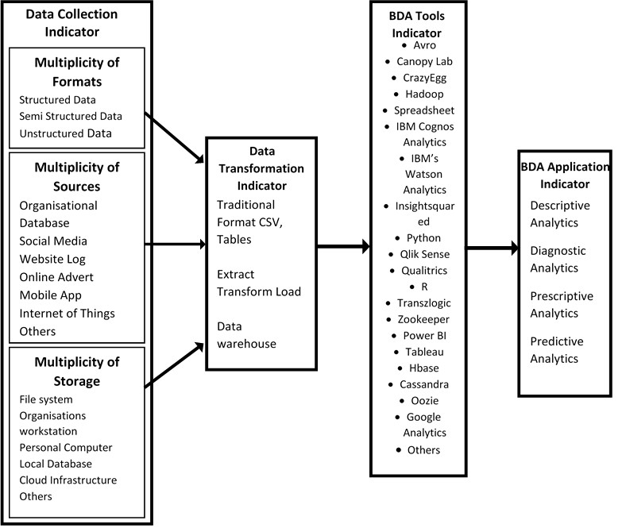
Figure 2.1: Conceptual Framework for Assessment of Big Data Analytics Adoption.
However, for some tools, data can remain in the traditional format of tables and CSV files for cleaning and preparation. Therefore, the phase of data transformation may not be a separate one from the tools for analytics. The third phase of the model architecture is concerned with the selection of BDA tools relevant to several organizations. BDA tools may include Hadoop, Pig, Hive, Map Reduce, Google Analytics, IBM Watson Analytics, Canopy Lab to mention a few.
The final phase of the architecture illustrates the actual applications of BDA in the organization. MFBs may perform descriptive, diagnostic, predictive, or prescriptive analysis. The descriptive analytics aims to get insight of what is happening from a given dataset or to describe a set of historical data. On the other hand, diagnostic analytics seeks to answer the question of why something happened from a given dataset with the goal of identifying the source of a problem. Predictive analytics uses current data and creates scenarios on what might happen in the future, using a variety of approaches such as data mining, and artificial intelligence (Riahi & Riahi, 2018). And the prescriptive analytics, answers questions of what should be done, identifying chances to improve the current situation based on the available data.

METHODOLOGY
This study adopts a descriptive survey research design to assess the adoption of BDA among MFBs. The researcher used a cross-sectional survey and a total enumeration of the entire population of the 35 MFBs operating in the Ibadan metropolis. However, two MFBs could not be located by their given addresses. Also one out of the thirty-three remaining MFBs was not operational at the time of the visit while four MFBs did not agree to participate in the study. Therefore, the total number of MFBs that participated in the study was twenty-eight (28). Data was collected using a well-structured questionnaire administered to relevant respondents in each MFB. Two copies of the questionnaire were administered to key personnel like, chief executive officer, managing directors, general Managers, Head of IT, Data Analyst, and Head of Operation. A total of fifty-six (56) copies of the questionnaire was administered, retrieved and analysed for the study. Data collected was analysed using descriptive and inferential analysis.
To determine the adoption index, Bui et al. (2003) e-readiness index formula was adapted. To situate the formula within BDA rather than e-readiness context, BDA indicators, as provided by the BDA architecture framework by Raghupathi and Raghupathi (2014), were supplied as indicators in the adapted formula. Hence, using the four indicators from the conceptual BDA architecture framework by (Raghupathi & Raghupathi, 2014) into Bui et al. (2003) e-readiness index formula, a Big Data Analytics Adoption index was derived as:
Big Data Analytics Adoption index
where BDA adoption index refers to the level of big data analytics adoption.
j: each of the four (4) indicators in BDA architecture framework by (Raghupathi & Raghupathi, 2014).
wj: relative weights assigned to the four (4) indicators (the assigned weight of 1 was used across all the indicators).
ej: individual index score for each indicator on a scale of 1 to 4.
n: total number of indicators (4).

PRESENTATION OF FINDINGS
Demographic Distribution of Organisations’ Profile
The demographic information of the organisations as described by the representative of the microfinance banks that participated in the study. These include; positions occupied by representatives in the organisation, size of the organization, years of business operation, and category of microfinance bank. The results of the demographic distribution are presented in Table 4.1.

Demographic Variables
Respondents’ Position in the Organisation | Frequency | Percentage (%)
Branch Manager | 3 | 5.4
Data Analyst | 4 | 10.7
Database Administrator | 2 | 3.6
Head of unit (Accounts) | 7 | 12.5
Head of unit (Admin) | 8 | 14.3
Head of unit (Operations) | 8 | 14.3
Head of (Human Resources) | 1 | 1.8
Head of unit (Internal Audit) | 2 | 3.6
IT Manager | 11 | 19.6
Managing Director | 4 | 7.1
Total | 56 | 100
Size of Organization (Staff) | Frequency | Percentage (%)
0 – 9 | 11 | 19.6
10 – 49 | 33 | 58.9
50 – 199 | 12 | 21.4
Total | 56 | 100
Years of Business Operation | Frequency | Percentage (%)
0 – 5 years | 7 | 12.5
6 – 10years | 17 | 30.4
Above10 years | 32 | 57.1
Total | 56 | 100
Type of Microfinance Bank | Frequency | Percentage (%)
Tier 1 unit | 25 | 44.6
Tier 2 unit | 9 | 16.1
State | 10 | 17.9
National | 12 | 21.4
Total | 56 | 100

Table 4.1 Demographic Distribution of Organisations’ Profile
As shown in Table 4.1, the demographic distribution of the organisation’s profile (Microfinance banks) that participated in the study shows participants according to position in the organisation; 3 (5.4%) branch managers, 4 (10.7%) data analysts, 2 (3.6%) database administrators, 7 (12.5%) head of unit (accounts), 8 (14.3%) head of admin unit, 8 (14.3%) head of unit (operations), 1 (1.8%) head of unit (human resources), 2 (3.6%) head of unit (internal audit), 11 (19.6%) IT managers, and 4 (7.1%) managing directors. In terms of the organisation’s staff strength, 11 (19.6%) have 0-9 staff, 33 (58.9%) have 10-49 staff, while 12 (21.4%) have a staff strength of 50-199. Also, 7 (12.5%) of the Microfinance banks have been in operation between 0 – 5 years, 17 (30.4%) between 6 – 10 years, and 32 (57.1%) have been in operation for more than 10 years. Furthermore, 23 (44.5%) of the Microfinance banks are in the Tier 1 unit MFB category, 9 (16.1%) are in Tier 2 unit MFB category, 10 (17.9) are in the State category, while 12 (21.4) are in the National category.
Research Question One: What is the level of involvement in big data collection (multiplicity of sources, format and storage) by Microfinance Banks?
The different responses as regards the sources and format of data collected by Microfinance Banks are presented in Table 4.2.
What are the types of data used for data analysis in your organisation? | Frequency | Percentages (%)
Structured | 55 | 98.2
Semi-structured | 7 | 12.5
Unstructured | 16 | 28.6
What sources does your organisation generate data from?
Organizational Database | 52 | 92.6
Social Media | 13 | 23.2
Website log | 15 | 26.8
Online Advert | 9 | 16.1
Mobile App | 13 | 23.2
Internet of Things | 8 | 14.3
Others (Reports) | 1 | 1.8
How is the data generated by the organisation stored?
Data is stored using a file system | 43 | 76.8
Data is stored on the organisation’s workstations | 24 | 42.8
Data is stored on worker's personal computers | 21 | 37.5
Data is stored in a local database | 31 | 55.3
Data is stored in a cloud infrastructure | 12 | 21.4
Others (Offsite backup = 1, External backup = 1) | 2 | 3.6
Table 4.2: Frequency Distribution on Data collection (Sources, Format and Storage) Indicator
As shown in Table 4.2, as many as 55 (98.2%) respondents of the bank representatives indicated that they use structured data, 16 (28.6%) respondents indicated the use of unstructured data while only 7 (12.5 %) respondents indicated the use of semi-structured data. The organisational database is the major source of data for microfinance banks in the Ibadan metropolis, with 52(92.6%) responses, followed by website log with 15 (26.8%) responses, mobile app, and social media with 13 (23.2%) respectively, while online advert, internet of things and report has 9 (16.1%), 8 (14.3%), 1 (1.8%) responses respectively. Forty-three respondent (76.8%) of MFB stores data using a file system, 24 (42.8%) stores data on the organisation’s workstations, and 21 (37.5%) stores data on workers' personal computers, 31 (55.3%) on the organisation’s local database, 12 (21.4%) uses cloud infrastructure, and 2 (3.6%) stores data using offsite/external backup.
Research Question Two: What are the strategies for data transformation and the types of analysis performed by Microfinance Banks?
The responses as regards the strategies for data transformation adopted by Microfinance Banks are presented in Table 4.3.
Before data is analysed what strategy is used to transform (prepare) data from the raw format in different sources to the format suitable for data analytics tools? | Frequency | Percentage (%)
Use of Extract, Transform and Load (ETL) model | 30 | 53.6
Use of Data Warehouse | 9 | 16.1
Use of Middleware software | 10 | 17.8
Use of Traditional format of CSV, Tables | 36 | 64.3
Table 4.3: Frequency Distribution of the Strategies for Data Transformation by Microfinance Banks
As shown in Table 4.3, the data transformation is performed by 36 (64.3%) respondents of the microfinance banks using the Traditional format of CSV and spreadsheet application, 30(53.6%) respondents indicated the use of Extract, Transform and Load (ETL) model, while 9 (16.1%) and 10(17.8%) responded to using data warehouse and middleware software respectively.

Research Question Three: What are the types of analyses performed by microfinance banks in Ibadan metropolis?
The responses as regards the types of analyses performed by Microfinance Banks are presented in Table 4.4.
What type of analysis is performed on data generated by your organisation? | Frequency | Percentages (%)
Descriptive Data Analytics | 48 | 85.7
Diagnostic Data Analytics | 24 | 42.9
Prescriptive Data Analytics | 27 | 48.2
Predictive Data Analytics | 34 | 60.7
Table 4.4: Frequency Distribution of the Types of Analysis Performed by Microfinance Banks
Table 4.4 shows the different kinds of analysis performed on data by microfinance banks in the Ibadan metropolis, However, 48(85.7%) respondents, commented that the type of analysis performed on data generated by their organisation is descriptive, 34(60.7%), commented on predictive data analytics, while 27(48.2%) and 24(42.9%) commented on prescriptive data analytics and diagnostic data analytics respectively.
Research Question Four: What are the Data Analytical tools and technologies used by Microfinance Banks in Ibadan?
The different responses as regards the Big Data Analytical tools and technologies used by Microfinance Banks in Ibadan are presented in Table 4.5.
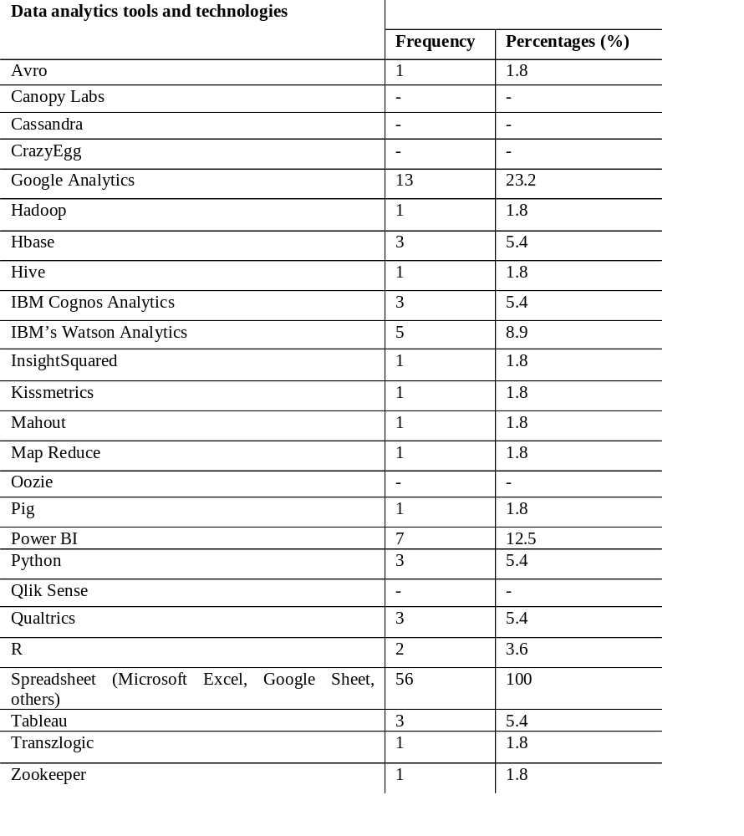

Table 4.5: Frequency distribution of Big Data Analytical tools and technologies used by Microfinance Banks in Ibadan
As shown in Table 4.5, in the list of the various tools and technologies used by MFBs in the Ibadan metropolis. Fifty-six (100%) respondents, which represents the total number of participants in the study, affirmed that they use Spreadsheet (Microsoft Excel, Google Sheet and others). Also, a considerable number of the respondent, 13 (23.2%), agreed that they use Google Analytics. However, the table shows that aside, from spreadsheet and google analytics, the majority of the respondent disagreed with the use of tools like Cassandra, Hadoop, and IBM’s Watson Analytics respectively. Also, the respondents in good numbers revealed the non-use of Transzlogic 53 (94.6%), Qlik Sense 56 (100%), and Power BI 49 (87.5%). Conclusively, it is evident that the major analytics tool used by microfinance banks for data analysis is the spreadsheet (Microsoft Excel, Google Sheet); while only a few of them use tools like, Google Analytics, Power BI, and Tableau.
Research Question Five: What are the Perceived Benefits of Big Data Analytics to Microfinance Banks in Ibadan?
The different responses as regards the perceived benefits of Big Data Analytics by Microfinance Banks in Ibadan are presented in Figure 4.1.
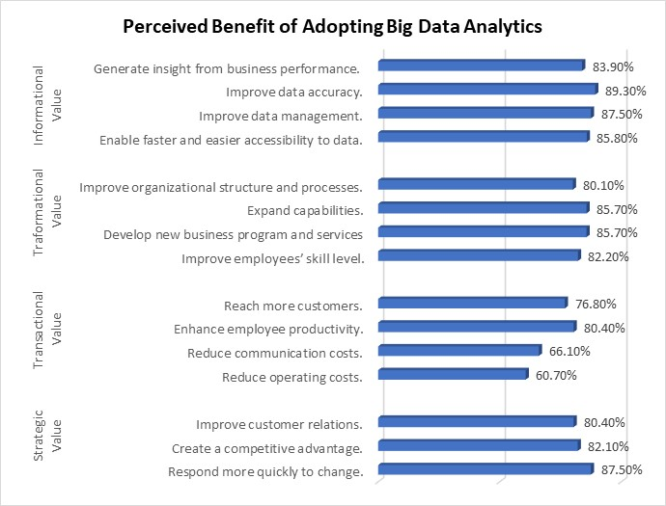
Fig. 4.1: Frequency distribution of the perceived benefit of using Big Data Analytics by Microfinance Banks in Ibadan
As shown in Figure 4.1, the perceived benefit of adopting BDA by Microfinance Banks in Ibadan metropolis, reports adoption for various perceived benefits. For strategic value, 49 (87.5%) respondents agreed that BDA help to respond more quickly to change. Also, as many as 46 (82.1%) agreed that BDA creates a competitive advantage for the organisation. Likewise, 45 (80.4%) agreed that BDA improves customer relations. In terms of transactional value, 34 (60.7%) of the respondents agreed that BDA will reduce operating costs. Also, 37 (66.1%) agreed that BDA reduces communication costs. Forty-five (80.4%) agreed that BDA enhances employee productivity and 43 (76.8%) agreed that BDA helps them to reach more customers. With respect to the transformational value, 46 (82.2%) of the respondents agreed that BDA improves employees’ skill level, 48 (85.7%) also agreed that BDA expands capabilities and helps to develop new business programs and services, 44 (81.5%) agreed that BDA improves organizational structure and processes. In addition, in terms of informational value, 48 (85.8%) of the respondents agreed that BDA enables faster and easier access to data. Also, 49 (87.5%) agreed that BDA improves data management. Meanwhile, 50 (89.3%) and 47 (83.9%) agreed that BDA improves data accuracy and helps to generate insight from business performance respectively.
Research Question Six: What are the perceived challenges encountered by Microfinance Banks in the adoption of Big Data Analytics
The different responses as regards the challenges encountered in using Big Data Analytics among Microfinance Banks in Ibadan are presented in Figure 4.2.
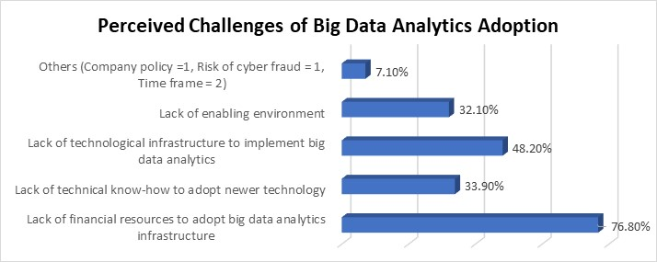
Fig. 4.2 Perceived Challenges of Big Data Analytics Adoption by Microfinance Banks in Ibadan.
Data in Figure 4.2 shows the distribution of the responses on perceived challenges in the adoption of BDA by Microfinance banks in the Ibadan metropolis. As many as 43 out of 56 (76.8%) comments by the respondents indicated that the lack of financial resources to adopt BDA infrastructure is the major challenge for the adoption of BDA. For 27 out of 56 (48.2%) respondents, lack of technological infrastructure to implement big data analytics, while 19 out of 56 (33.9%) and 18 out of 56 (32.1%) respondents indicated a lack of technical know-how to adopt newer technology and lack of enabling environment respectively as challenges encountered by Microfinance banks in the adoption of BDA. Some respondents identified other challenges, 1 out of 56 (1.8%) indicated company policy and risk of cyberfraud respectively, and 2 out of 56 (3.6%) respondents indicated time as a perceived challenge to the adoption of BDA.
Based on these findings, it can be said that the major challenges encountered by Microfinance banks in the adoption of big data analytics are; the lack of financial resources to adopt new BDA infrastructure, Lack of technological infrastructure to implement big data analytics, Lack of technical know-how to adopt newer technology, and lack of enabling environment among others.
Research Question Seven: What is the MFBs level of BDA adoption based on its indicators’ indices?
To determine the level of adoption of BDA among microfinance banks in Ibadan. The four (4) adoption indicators; data collection indicator, data transformation indicator, BDA tools and technologies indicator, and application of BDA indicator are used to determine the BDA adoption index. The indices of the indicators and their parameters are computed using the Bui et al. (2003) formula. An overall index for microfinance banks’ BDA adoption and the contributory indices were determined. The relative weight parameters index is measured on a scale of 1-4 in percentage, index 1 is 0-25%, index 2 is 26-50%, index 3 is 51-75%, and index 4 is 76-100%. The data collected for the Big Data Analytics adoption indicators and their various indices are presented in Table 4.6.

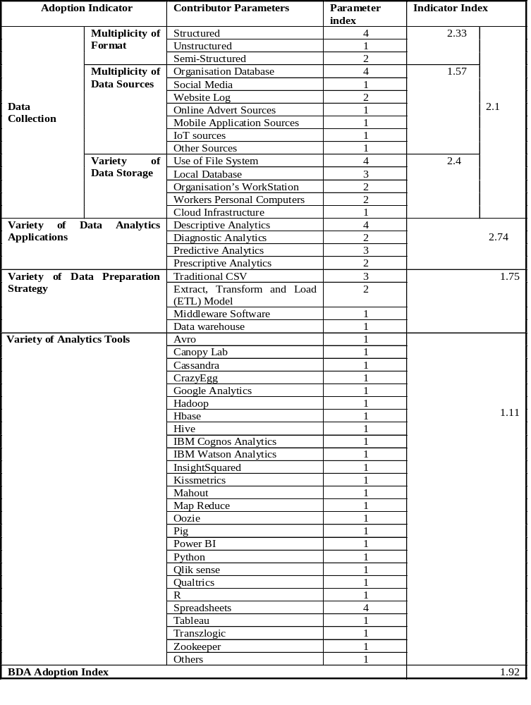Table 4.6 Big data analytics adoption indicator and indices of microfinance banks in Ibadan.

The overall adoption index for big data analytics among MFB in Ibadan metropolis as seen from Table 4.6 = (2.1+2.74+1.75+1.11)/4
The overall BDA adoption index for MFB in Ibadan metropolis = 1.92.

DISCUSSION OF FINDINGS
The findings of the study reveal that the major type of data used among microfinance banks in Ibadan is structured data. This implies that many microfinance banks in Ibadan are not yet using unstructured and semi-structured data. According to Harbert (2021), because most of the world's data is unstructured, including most real-time data, the ability to analyse and act on it represents significant potential. Therefore, this signifies that a reasonable number of the MFBs in the Ibadan metropolis have not yet tapped into the potential of unstructured data such as web pages, data from social media, customers' emails, audios, images, videos and so on. This may be because unstructured data are more difficult to manage and requires more expertise and specialized tools in order to fully utilize them. However, it is a rich source of data that has the potential for great business intelligence and analytics.
The major sources of data being organisational database and the major storage being the file system poses a limitation on the type of data being used and the type of analysis that can be performed. Most microfinance bank applies analysis for descriptive purposes. This implies that MFBs analyse past data to summarize or describe data to get an insight into what has happened. This may be due to the nature of their operation and the kind of data they capture or their perceived need for data analytics. Descriptive data analytics is relevant when organisations need to present charts, reports, graphs and dashboards. However, MFBs in the metropolis are still lagging in the use of predictive, diagnostics and prescriptive analysis.
The major tools and technologies used by microfinance banks for data analysis are Spreadsheet (Microsoft Excel, Google Sheet) and Google Analytics. This is in congruence with the finding on the type of data used by MFB in Ibadan which revealed structured data to be the most used data type. The sources of data also reveal that majority of MFBs in Ibadan source data for analysis from their organisational database, which uses structured data. Hence, this may be the reason why the use of spreadsheets as an analytic tool cut across all microfinance banks in Ibadan. The analytics tools used by MFB are considered primitive and are not suitable for big data storage, transformation and analysis. The tools currently indicated to be in use cannot be used for advanced data analytics.
The perceived challenges of Microfinance banks in the adoption of big data analytics is lack of financial resources to adopt new big data analytics infrastructure, lack of technological infrastructure to implement big data analytics, lack of technical know-how to adopt newer technology, lack of enabling environment among others. These challenges are typical of the challenges of adopting new technologies among relatively small businesses. MFBs may consider the financial implication of adopting BDA to be a challenge as they are typically small in size and many MFBs may not be able to afford the implementation of such technology. Also, many of the microfinance banks may not be having professional data analysts. Big data analytics requires trained and skilled personnel who can use new and advanced data analytics tools. This is in agreement with the submission of Apulu and Ige (2011) that many small organisations do not have the technological infrastructure, financial capacity and technical know-how to adopt new technologies. Microfinance banks in Ibadan also perceived the adoption of BDA to be beneficial to business operations. This means that many of these organisations are not ignorant of the potential benefit of adopting BDA, they are positive about it being a strategic tool to improve their businesses. This also may imply that MFB may be motivated to adopt big data analytics if necessary support is offered or if managers and major stakeholders give the right hand of support to promote the initiative. According to Maroufkhani et al. (2020), top management support and support from vendors can greatly influence the adoption of BDA.
The overall BDA adoption index among MFB in the Ibadan metropolis is 1.92, on a scale of 1-4, indicates that MFBs adoption level is below average. This is considered a very low level of adoption. Two out of the four indicators have just above average scores, these are the data collection indicator [2.1 (52%)] and BDA Application [2.74 (68.5%)]. While the remaining two indicators (Data Transformation Strategy and BDA Tools) are below average with adoption scores of [1.75 (43.75%)] and [1.11 (27.75%)] respectively.

CONCLUSION AND RECOMMENDATION
Based on the findings of this study, it can be concluded that the major type of data used among microfinance banks in the Ibadan metropolis is structured data. The organisational database serves as the primary source of data. Data is mostly stored using a file system or in the local database. Furthermore, the major type of analysis performed is descriptive data analysis. Data is transformed mostly by using the traditional format of CSV format using spreadsheets. Spreadsheets (Microsoft excel, google sheet and other) is the major tool used for data analysis.
The major challenges to the adoption of BDA are the lack of financial resources and technological infrastructure. BDA perceived benefits among MFB include, Strategic value, Transactional value, Transformational value and Informational value. The BDA adoption index of microfinance banks in the Ibadan metropolis is rated as 1.92, this signifies a very low level of adoption. This signifies that BDA among MFB in Ibadan has not been fully embraced.
As a result of the findings from this study, the following recommendations are made:
- Regulatory bodies like CBN and the National Association of Microfinance Banks (NAMB) should partner with BDA vendors that offer data analytics solutions, to train MFB technical staff on how to leverage data analytics solutions in their business operations.
- The technology companies that provide data analytics solutions should begin to develop BDA solutions customised and relevant for microfinance banks in Nigeria, considering their peculiar needs and their budget.
- The Federal Government and CBN could make policies that promote, encourage, and mandate proper big data management, storage and use among MFBs in Nigeria.
- Managers, MFBs owners, data analysts, and technical staff in microfinance should look out for alternative and more advanced data analytics tools which are cheap or completely free to meet their data analytics needs.
- The Indigenous technological companies can take advantage of the situation at hand and look for ways to penetrate the sector by providing technological solutions that will enhance and promote the adoption of big data analytics among MFBs in Nigeria.

REFERENCES

Normal or Body Text
Please use a 12-point Times New Roman font or, if it is unavailable, another proportional font with serifs, as close as possible in appearance to Times New Roman 12-point. On a Macintosh, use the font named Times and not Times New Roman. Please use sans-serif or non-proportional fonts only for special purposes, such as headings or source code text.
The body of the article may include text, tables, and figures only in order to ensure the widest accessibility even in less technologically endowed environments. The body of the article should represent a stand-alone document. Links and multimedia supplements may be included in one or more appendices. Readers will have the option of downloading articles with such appendices as HTML documents.
Submission of an article to the AJIS implies the authors’ certification that the manuscript is not copyrighted and is not currently under review by any other journal or conference proceedings. If it is found that this requirement has not been followed, the paper will be rejected.

References and Citations
Please use the reference format that you see illustrated at the end of this paper. If you are using EndNote, you are urged to upgrade to Version X9 because it will allow you to add the APA 7th edition reference formatter. However, even if you are using EndNote, check your references to ensure that they have been formatted correctly. Likewise, if you are using different software to format your references, double-check output for APA 7th edition style consistency.

In the text, cite by authors’ last names followed by the year of publication. If there are two authors, list both of names in every instance, whether in the signal phrase, as in: Jones and Smith (2019) say . . ., or parenthetically: (Jones & Smith, 2019). Note that the word “and” is used in the signal phrase, and the ampersand (&) is used parenthetically. If there are three or more authors, then, in every instance, list only the last name of the first author, followed by et al., in both the signal phrase and parenthetically. If this creates ambiguity, then list enough names, followed by et al., to negate the ambiguity. If multiple articles are cited at the same time, order them alphabetically by the first author’s last name and separate the citations by semicolons. If the same author(s) has/have more than one article being cited, use chronological order and separate the year of publication of the articles by commas. For example: (Agarwal & Karahanna, 2000; Ajzen, 1988, 1991; Zhang et al, 2002). Later in the paper, you may cite some of them again, along with others, as follows: (Agarwal & Karahanna, 2000; Ghani et al, 1991; Shneiderman, 1998; Tractinsky, 1997; Zhang et al., 2002). Please note that the APA 7th edition rules regarding such things as the number of authors to include in citations differs for the reference section, hence, it is best to consult the APA Style Manual, 7th edition, for guidance.
Your references should comprise only published materials accessible to the public. Proprietary information may not be cited.

Subsections
Headings of subsections should be in Ariel 12-point bold with initial letters capitalized (Heading 2). (Note: for sub-sections and sub-subsections, a word like ‘the’ or ‘of’ is not capitalized unless it is the first word of the heading.)

Sub-subsections
Headings for sub-subsections should be in Ariel 12-point italic with initial letters capitalized (Heading 3). Please do not go any further into another layer/level.

Inserting Images
Occasionally MS Word generates larger-than-necessary PDF files when images inserted into the document are manipulated in MS Word. To minimize this problem, use an image editing tool to resize the image at the appropriate printing resolution (usually 300 dpi), and then insert the image into Word using Insert | Picture | From File. As indicated in Figure 1, using tables to hold places can work very well in Word. If you want to copy a figure from another application (such as PowerPoint) and then paste it to the place where you want your figure to be, make sure that (1) the figure stays in the position, and (2) it does not take up too much space. You can ensure the former by double clicking the figure, then go to “Layout” tab, and select “In line with text.” To ensure the latter, use “Paste Special,” then select “Picture.” You can resize the figure to your desired size once it is pasted. Cite and reference the sources for images, tables, and figures if they were not generated by the author(s).

Table Style
Inserting a table in the text can work well. See Table 1 below. The text of tables will format better if you use the special Table Text style (in this template file). Note that vertical borders are not used between columns. If you do not use this style, then you may want to adjust the vertical spacing of the text in the tables. (In Word, use Format | Paragraph . . . and then the Line and Page Breaks tab. Generally, text in each field of a table will look better if it has equal amounts of spacing above and below it, as in Table 1.)

Table 1
This is a Nice and Tidy Table
 | Treatment 1 | Treatment 2
Setting A | 125 | 95
Setting B | 85 | 102
Setting C | 98 | 85
Note. A table note such as this example is an option to explain, supplement, or calrify information in the table body. It also can be used to attribute the source of the table.

FIGURES/CAPTIONS
Place figures and tables close to the relevant text (or where they are referenced in the text). Captions should be Times New Roman 10-point bold (Caption Style in this template file). Table # and Figure # should be boldbaced (e.g., “Table 1” or “Figure 2”), and the caption should be italicized. These elements should be placed flush left over a table and, depending on the nature of a figure, placed flush left or centered over the figure. . Please note that the words “Figure” and “Table” should be spelled out (e.g., “Figure” rather than “Fig.”) wherever they occur.
Figure 1
The AJIS Logo


The journal will be made available online, thus color figures are possible. However, you are advised to refrain from using more than one emphasis (color, bold, italic, underline, caps, etc) at a time. For example, avoid underline and bold or italic and bold or italic and underline for the same word.

LANGUAGE, STYLE AND CONTENT
With regard to spelling and punctuation, for the sake of consistency, you are required to use American English. To ensure suitability for an international audience, please pay attention to the following:
- Write in a straightforward manner which adheres to the American Psychological Association Publication Manual (APA) 7th Edition (2020).
- All articles submitted to the AJIS must focus on an information systems’ issue that relates specifically and substantively to an African country or countries.
- Please indicate in your introduction the type of article you have submitted (e.g., quantitative, qualitative, etc.).
- Try to avoid long or complex sentence structures.
- Insert Em dashes (—) without spaces between words. Create an em dash either by using two dashes (--) or by using the Alt code (Alt + 051).
- Briefly define or explain all technical terms that may be unfamiliar to readers.
- Explain all abbreviations and acronyms the first time they are used in your text—e.g., “Digital Library (DL)”.
- Explain local references (i.e., not everyone knows all city names in a particular country).
- Avoid referring to African countries as “developing.” You may indicate that a certain aspect of an African country is developing, such as the economy (e.g., “developing economy” or “developing economies”).
- Be careful with the use of gender-specific pronouns (he, she) and other gendered words (chairman, manpower, man-months). Use inclusive language that is gender-neutral (e.g., she or he, they, s/he, chair, staff, staff-hours, person-years; plural pronouns, such as they, them, and their may be used as a singular, non-gendered pronoun [e.g., Each author should prepare their manuscript carefully]).

Page Numbering, Headers and Footers
Please submit your final version with the pre-defined header and footer. Insert your name (only the first author’s last name, and use “et al.” after that if the paper has more than one author) and a short title of your paper in the header. Leave the footer untouched. Use the default page number shown in this document. Page numbers in the final document will be adjusted by the managing editors.

Conclusion
It is important that you write for a general audience. It is also important that your work is presented in a professional manner. This submission template is designed to help you achieve that goal. By adhering to the template, you also help the managing editors tremendously by reducing their workload and ensuring the impressive presentation of your journal paper. The AJIS thanks you very much for your cooperation and looks forward to receiving your attractive, camera-ready version!

ACKNOWLEDGMENTS (Optional)
We thank all authors, committee members, and volunteers for their hard work and contributions to the journal. The layout of this format was adapted from a workshop document created by Ping Zhang (used here by permission from the author). The content was adapted for the AJIS template. The references cited in this paper are included for illustrative purposes only.

REFERENCES
Amakobe, M. A. (2015). The Impact of Big Data Analytics on the Banking Industry. Colorado Technical University, 1–5.
Apulu, I., & Ige, E. O. (2011). Are Nigeria SMEs Effectively Utilizing ICT ? International Journal of Business and Management, 6(6), 207–214. https://doi.org/10.5539/ijbm.v6n6p207
Attaran, M., Stark, J., & Stotler, D. (2018). Opportunities and Challenges for Big Data Analytics in American Higher Education- A Conceptual Model for Implementation Opportunities and challenges for big data analytics in US higher education: A conceptual model for implementation. Industry and Higher Education, May, 1–14. https://doi.org/10.1177/0950422218770937
Ayers, R. (2020). How Small Businesses Can Take Advantage of Big Data - business.com. https://www.business.com/articles/data-analysis-for-small-business/
Bhagat, V. (2020). Datafloq: Datafloq is the One-Stop source for Emerging Tech – Contact Us. https://datafloq.com/contact/
Bui, T., Sankaran, S., & Sebastian, I. M. (2003). A framework for measuring national e-readiness. International Journal of Electronic Business, 1(1), 3–22.
Bulao, J. (2021, May 18). How Much Data Is Created Every Day in 2021? [You’ll be shocked!]. Techjury. https://techjury.net/blog/how-much-data-is-created-every-day/
Cautero, R. (2021, May 21). ​What Is Microfinance and Why Is It Important? https://www.thebalance.com/what-is-microfinance-and-how-does-it-work-4165939#citation-1
Frankenfield, J. (2021). Data Analytics Definition. Investopedia. https://www.investopedia.com/terms/d/data-analytics.asp
Ghasemaghaei, M. (2018). Improving organizational performance through the use of big data. Journal of Computer Information Systems, 1–14.
Groenfeldt, T. (2012). Big data – big money says it is a paradigm buster. Forbes.
Haddad, A., Ameen, A. A., & Mukred, M. (2018). The Impact of Intention of Use on the Success of Big Data Adoption via Organization Readiness Factor. International Journal of Management and Human Science (IJMHS), 2(1), 43–51.
Harbert, T. (2021, February 1). Tapping the power of unstructured data | MIT Sloan. https://mitsloan.mit.edu/ideas-made-to-matter/tapping-power-unstructured-data
Iqbal, M., Soomrani, A. R., & Butt, S. H. (2018). Opportunities & Challenges. 2018 International Conference on Computing, Mathematics and Engineering Technologies (ICoMET), 1–7.
Joubert, A., Murawski, M., & Bick, M. (2021). Measuring the Big Data Readiness of Developing Countries – Index Development and its Application to Africa. Information Systems Frontiers. https://doi.org/10.1007/s10796-021-10109-9
Joubert, A., Murawski, M., & Bick, M. (2019). Data Readiness Index – Africa in the Age of Analytics. Digital Transformation for a Sustainable Society in the 21st Century., 101–112.
Kagan, J. (2021, July 21). Microfinance Definition. https://www.investopedia.com/terms/m/microfinance.asp
Kauffman, R., & Riggins, F. (2010). Research directions on the role and impact of ICT in Microfinance. Proceedings of the 43rd Hawaii International Conference on System Sciences, 1–10.
KPMG International Cooperative. (2019). Data as an asset - Capitalize on data’s near limitless value to exploit its power. 1–16. https://assets.kpmg/content/dam/kpmg/xx/pdf/2019/10/data-as-an-asset.pdf
Kuznetsova, V., Azhmuhamedov, I., & Protalinskiy, O. (2020). Social Media Analytics for Better Detection of Fraudulent Applications for Online Microfinance Loans (pp. 1–4).
Maroufkhani, P., Tseng, M. L., Iranmanesh, M., Ismail, W. K. W., & Khalid, H. (2020). Big data analytics adoption: Determinants and performances among small to medium-sized enterprises. International Journal of Information Management, 54(February), 1–15. https://doi.org/10.1016/j.ijinfomgt.2020.102190
Marr, B. (2018). How Much Data Do We Create Every Day? The Mind-Blowing Stats Everyone Should Read. Forbes . https://www.forbes.com/sites/bernardmarr/2018/05/21/how-much-data-do-we-create-every-day-the-mind-blowing-stats-everyone-should-read/?sh=4339d3f660ba
Murad, A. B., & Idewele, I. E. O. (2017). The impact of microfinance institution in economic growth of a country: Nigeria in focus. International Journal of Development and Management Review, 12(1), 1–17.
Mustapha, S. A. (2020). Credit Default Issue in Nigerian Microfinance Banks: Developing Sustainable Predictive Analytics System. African Economic Research Consortium, 1–11.
Nadikattu, R. (2020). Research on Data Science, Data Analytics and Big Data. International Journal of Engineering Science and Mathematics, 9(5), 99–105.
Ogbuokiri, Udanor C N, & Agu, M. N. (2015). Implementing bigdata analytics for small and medium enterprise (SME) regional growth. IOSR Journal of Computer Engineering Ver. IV, 17(6), 35–43. https://doi.org/10.9790/0661-17643543
Okafor, F. . (2000). Micro-credit: An instrument for economic growth and balanced development. African Banking and Finance Review, 1(1), 31–42.
Okoye, L. U., Adetiloye, K. A., Erin, O., & Modebe, N. J. (2016). Financial inclusion: A panacea for balanced economic development. 28th International Business Information Management Association (IBIMA), 4384–4394.
Okoye, L. U., Omankhanlen, A. E., Okoh, J. I., & Isibor, A. . (2018). Technology-based financial services delivery and customer satisfaction: A study of the Nigerian banking sector. International Journal of Civil Engineering and Technology, 9(13), 214–223.
Pamela, O. (2021, January 20). Big Data for Small Business: 8 SMB Data Solutions - businessnewsdaily.com. https://www.businessnewsdaily.com/6358-big-data-solutions.html
Polkowski, Z., Khajuria, R., & Rohadia, S. (2017). Big Data Implementation in Small and Medium Enterprises in India and Poland. Scientific Bulletin – Economic Sciences, 16, 149–161.
Raghupathi, W., & Raghupathi, V. (2014). Big Data Analytics Architectures, Frameworks, and Tools. IT Performance Improvement. http://www.ittoday.info/ITPerformanceImprovement/Articles/2014-07Raghupathi.html
Raguseo, E., & Vitari, C. (2018). Investments in big data analytics and firm performance: an empirical investigation of direct and mediating effects. International Journal of Production Research, 56(15), 1–16. https://doi.org/10.1080/00207543.2018.1427900
Riahi, Y., & Riahi, S. (2018). Big Data and Big Data Analytics: concepts, types and technologies. International Journal of Research and Engineering, 5(9), 524–528. https://doi.org/10.21276/ijre.2018.5.9.5
Russom, P. (2011). TDWI Research Big Data.
Ssewanyana, J. K. (2009). ICT Usage in Microfinance Institutions in Uganda. The African Journal of Information Systems, 1(3), 5–28.
Sykes, N. (2018). 9 Powerful Data Science and Analytics Tools for Small Business. https://www.kolabtree.com/blog/9-powerful-data-science-and-analytics-tools-for-small-business/
Villars, R., Olofson, C., & Eastwood, M. (2011). Big data: What it is and why you should care. IDC White Paper.
Vision Microfinance. (2021). What is Microfinance?: Vision Microfinance. https://www.visionmicrofinance.com/en/about-microfinance/about-microfinance
Wachukwu, I., Onyema, J., & Amadi, S. (2018). Effects of microfinance banks and economic growth in Nigeria. Journal Finance Marketing, 3(1), 15–19.
Yadav, S. (2021). Top 10 Data Science Tools for Small Businesses - DataFlair. https://data-flair.training/blogs/data-science-tools-for-small-businesses/
Zakir, J., Semyour, T., & Berg, K. (2015). Big data analytics. Issues in Information Systems, 16(2), 81–90. https://doi.org/10.48009/2_iis_2015_81-90

